Project Report Template

Cloud Kitechen

Contents

## Project Report Template

1. Definition of the Problem 3
2. Requirement Analysis 3
3. Design Phase 3
4. Architecture of Website 4
5. Evaluation/Testing 4
6. Project Tracking and Monitoring Activities 5
7. Documentation Section 6
8. Source Code 17
9. User Guide 17

Project Report Template

# Definition of the Problem

After reading the project specifications, the developer states the scope of the project very briefly. This is referred to as the problem definition.

For example, in the case of **GrubKing** portal, queries of various staff members can be one or all of the following:

1. How many dishes will be displayed on the order page at a time?
2. How many dishes will be displayed in different dining hours?
3. Where will the prices and addresses of the restaurant's restaurant will be displayed for users?
4. Will users contact the restaurant or restaurant they like to be displayed on the website?
5. Will the cafes or restaurant cooperate with Grubking contact the website to exchange work or not?

After consulting several IT companies and considering the budget constraints, the management of **GrubKing** has decided to launch the Web application as a Single Page Responsive Web application. Hence, the project will use HTML5, CSS3, JavaScript , JSON & text document, and Bootstrap 4 libraries from getbootstrap.com, jQuery plugins and Notepad++, or other HTML editors. Also, the site will be tested on popular browsers and mobile emulator software.

# Requirement Analysis

This stage includes the following:

➢ List of inputs for the system

➢ List of expected outputs from the system

➢ Overview of system-related processes

➢ Hardware and software needed to implement the project

➢ Customer acceptance criteria for the project

For example, in the GrubKing portal project, the goal will be:

• Is the interface of breakfast, lunch, dinner, snacks and drinks. Help users have more options in choosing

• Order and pay easily, conveniently and quickly

* **Input provided by the customer:**
* **Enter the existing system**
* **Output from the existing system**
* **The process of participating in the application**
* **Expected delivery date**
* **List of delivery**

**Hardware requirements:**

**• Intel Core i3 / i5 Processor or Higher**

**• 8 GB RAM or Above**

**• Color SVGA**

**• 500 GB Hard Disk Space**

**• Mouse & Keyboard**

**Software Requirements:**

* Windows 8, 10 or higher
* Browser supports HTML5 and JavaScript
* Bootstrap Library 3.3 from getbootstrap.com, jQuery and Coffeecup plugins, Notepad ++ or other HTML edits
* Interface (Frontend): HTML5, CSS3, Bootstrap, JavaScript, JQuery, AngularJS, Angular9 (Optional), XML
* Data (data store): JSON Files or TXT Files

### Scope of the work:

This electronic portal will be a visually responsive and attractive website for individuals to use. This portal will be designed to allow users to browse and select food items to be delivered. Payment and delivery functions are outside the scope of the project.

* Home for grubking portal will continue to display menu options to register / log in, with search and filter bars, order, pay, introduce and contact us.
* Register / log will lead to appropriate pages where users can register or log in if registered.
* Menu will display images of dishes, description of dishes, where the restaurant is made and some related information
* About Us and Contact Us should contain some relevant information.
* The user can view and visit the links of their favorite stores or restaurants.

# Design Phase

Design phase involves the preparation of the blueprint of the proposed system.

### Designing the GUI Standards

For grubking portals, multiple monitors must be created and linked together. Each of this screen needs a consistent look for the appearance and theme. Font styles, color labels, designs and interfaces of commands, the appearance of the title and footer, and the design and size of the controls, such as checkboxes or right text boxes Be consistent through all forms.

In case of grubking portal, the module can be for:

* + Registration
  + Login
  + Appointment

### Assigning and Monitoring Tasks

You are expected to fill in the task table as in the 'SWD / Form 7' document given in

The documentation of this project form.

You should fill in the final checklist in the 'SWD / Form 8' document given in the document

Part of this project form.

# Architecture of Website

Figure 1.1 displays the application architecture.

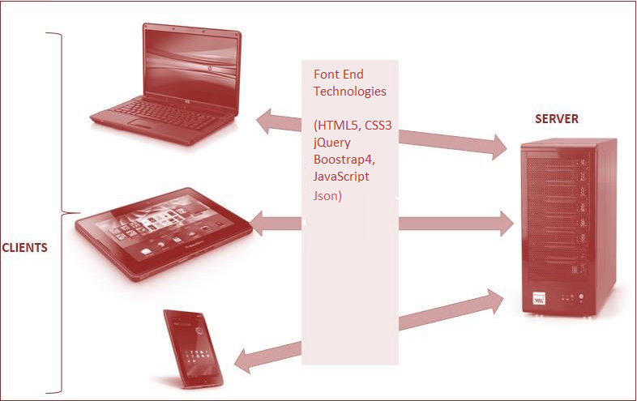

**SiteMap**

### Figure 1.1: Application Architecture

**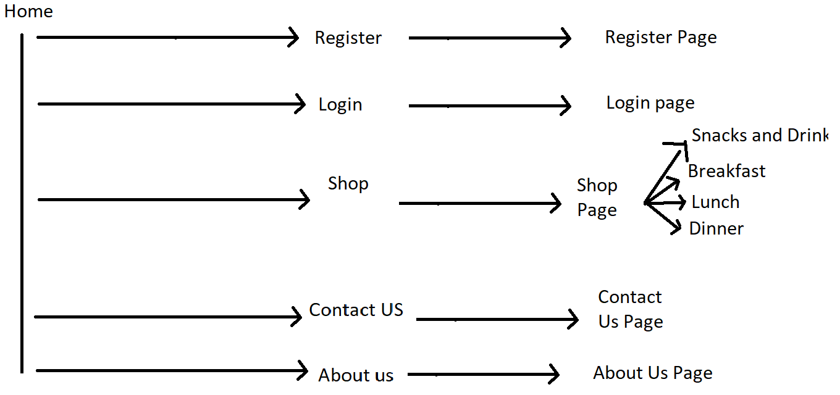  
Figure 1.2: SiteMap**

# Evaluation/Testing

This Is The Most Crucial Phase Where Each Unit is Tested for ITS Functionality. Test Data is Used to Check if The Module Is Able To Process It WHOUT CAUSING ANY ERRORS. Test Data May Be Live Data Extracted From Existing Records in The System or Dummy Data. Then, The Individual Tested Modules Are Integrated and Tested As A Whole Through ITS Various Paths. The Developed Specifications and Thumer Requirement Specifications Each of the Customer Requirement Specifications and Thus, Ensures that the Developed System Is Able To Resolve the Problem Definition Completely.

After Finishing the Project, Give It To Your Peers for Testing The Entire Project. The Project Should Be Verified For The Data Entered by the customer in the Various Forms. The Findings Can Be Records in The Document 'SWD / Form No. 8.

Project Report Template

# Project Tracking and Monitoring Activities

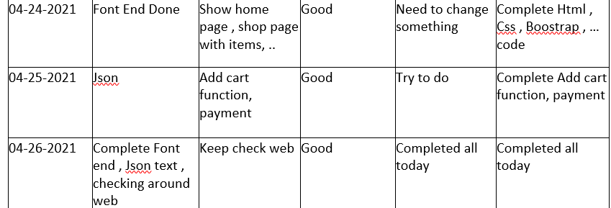

## Project Report Template

# Documentation Section

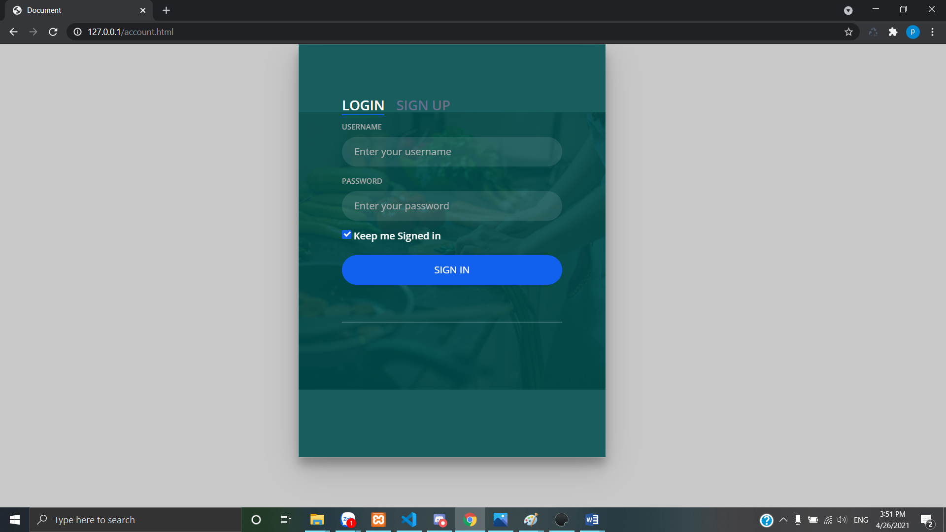

* Various forms required in the project

|  |  |  |
| --- | --- | --- |
| **Design Plan:** | **Document Name:**  **Problem Definition Document** | **SWD/Form No. 1** |
| **Effective Date:** | **Version: 1** | **Page No.** |

*Eating home cooking foods can sometimes be a luxury or even a time-consuming job considering the number of preparations. If a person exhausted after a hard working day or a sick person and could not cook, ordering online dishes could be a good alternative. Perhaps, a group of people suddenly visited your home and didn't have time or not available raw materials to cook an elaborate meal quickly for so many people. Ordering online will be an easy way.*

*Besides these things, there are many other cases where online feeding will be more reasonable than cooking at home.*

*According to a recent study conducted abroad, there may be a script that in 2030, most of the currently cooking meals at home are ordered online and delivered from Chinese restaurants or kitchen center. When restaurants and kitchens cooperate with online services to form collaboration, those services are called clouds (Clouds Kitchen).*

|  |  |
| --- | --- |
|  | **Prepared By (Student)** |
| **Date** | 04-24-2021 |

## Project Report Template

|  |  |  |
| --- | --- | --- |
| **Design Plan:** | **Document Name: Customer Acceptance Criteria (CRS)** | **SWD/Form No. 2A** |
| **Effective Date:** | **Version: 1** | **Page No.** |

Client/Project Undertaken:

### List of inputs to the system

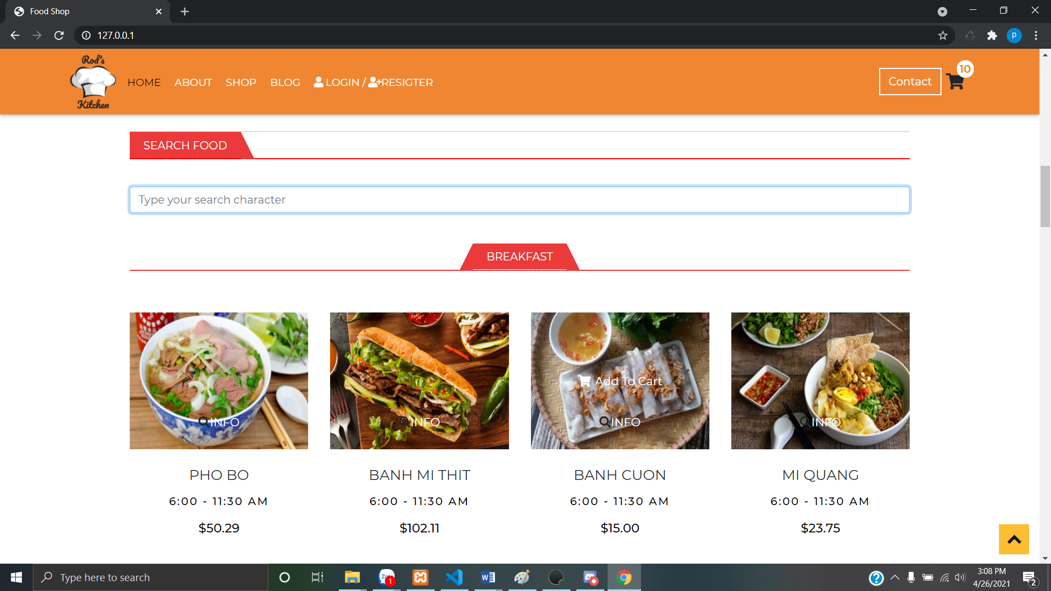

1. **List of outputs expected from the system**

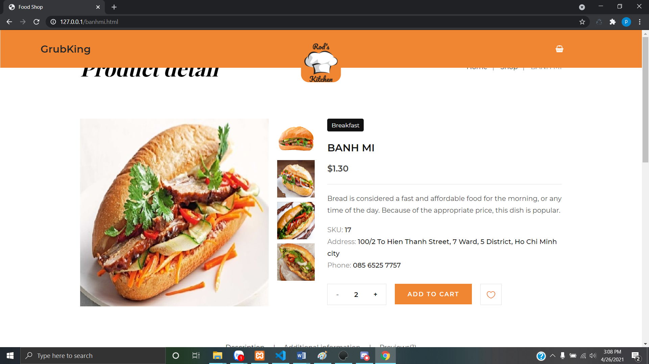

1. **Overview of Processes involved in the system**

**The suggested website for online dishes will be named Grubking and its goal will be allowing people to look through the online restaurant menu and place food online.**

1. **Hardware and Software required for implementing the project**

**Hardware requirements:**

**• Intel Core i3 / i5 Processor or Higher**

**• 8 GB RAM or Above**

**• Color SVGA**

**• 500 GB Hard Disk Space**

**• Mouse & Keyboard**

**Software Requirements:**

* Windows 8, 10 or higher
* Browser supports HTML5 and JavaScript
* Bootstrap Library 3.3 from getbootstrap.com, jQuery and Coffeecup plugins, Notepad ++ or other HTML edits
* Interface (Frontend): HTML5, CSS3, Bootstrap, JavaScript, JQuery, AngularJS, Angular9 (Optional), XML
* Data (data store): JSON Files or TXT Files

|  |  |
| --- | --- |
|  | **Prepared By (Student)** |
| **Date** | 04-24-2021 |

Project Report Template

|  |  |  |
| --- | --- | --- |
| **Design Plan:** | **Document Name: CRS** | **SWD/Form No. 2B** |
| **Effective Date:** | **Version: 1** | **Page No.** |

|  |  |
| --- | --- |
| **S.No.** | **Customer’s Acceptance Criteria** |
| 1. | Delivery time |
| 2. | Food quality |
| 3. | Aesthetic dish |
| 4. | Dish price |
| 5. | Diversity of dishes and beverage foods |
| 6. | Web speed fast, full |
| 7. | How to order and pay simple and fast |
| 8. |  |
| 9. |  |
| 10. |  |

|  |  |  |
| --- | --- | --- |
|  | **Prepared By (Student)** |  |
| **Date** | 04-25-2021 |  |

Project Report Template

|  |  |  |
| --- | --- | --- |
| **Design Plan:** | **Document Name: Project Plan** | **SWD/Form No. 3** |
| **Effective Date:** | **Version: 1** | **Page No.** |

**Project Plan**

1. **Project Details**
   * **Name of the Client: Grub King (Cloud Kitchen)**
   * **Date of the Project Plan: 04-24-2021 to 04-26-2021**
   * **Project Vision/Objectives:**

(Define the project vision/objectives as stated by the client)

The purpose of this document is to present a detailed description of Cloud Kitchen app or online food delivery, with grubking titles.

Through grubking, individuals can look through breakfast, lunch and dinner dishes as well as snacks and choose any dish and with the number they want. They can specify the address for delivery and see the bill has been calculated.

This document explains the purpose and features of the website, the interfaces of

Website, what websites will do and the constraints that it must operate.

This document is for both stakeholders and developers of the website and will be proposed to approved customers.

### Scope:

(Mention the scope of the project giving the location that will be covered, processed, range of services, and so on)

This electronic portal will be a visually responsive and attractive website for individuals to use. This portal will be designed to allow users to browse and select food items to be delivered. Payment and delivery functions are outside the scope of the project.

### Our understanding of the client organization

(Give the range of services, functions, overview of processes, and so on)

The portal will be designed as a single-page-application) page and the site responds to a set of pages and menus that represents the selection of activities that will be done. Pages, menus and other image elements must be designed in an attractive visual way with fonts, colors and attractive animations. All of this should also be presented in a response way.

### Project Organization with Responsibilities and Authorities Team T1.2011.M0

### Vũ Trọng Phong Student1285594

### Lê Ngân Tâm Student1288146

### Phạm Thiên Long Student1285597

### Đỗ Huy Hoàng Student1288223

### Đỗ Thành Nam Student1286087

### Nguyễn Hoàng Minh Student1287968

(Give the name of Project team members their roles and responsibilities)

## Project Report Template

### Project Initiation/Requirement Documents

(Information required from the client as inputs regarding his/her system; could be the information about the services, processes, and so on)

The system must meet some non-functional requirements.

The system must:

Safe use (Safe to use): The system will not lead to any malicious downloads or downloading unnecessary files.

Accessible (accessible): The system must have clear and easy-to-read fonts, user interface elements and navigation elements.

User-friendly (User-Friendly): The system must be easy to navigate with clear menus and other elements and easy to understand.

Operation ability: The system must operate effectively.

Performance (Performance): The system must demonstrate high value of performance through speed and throughput. In understanding, the system must quickly download and redirect the page to be smooth.

Availability (availability): The system must operate 24/7 with minimum deactivity.

Compatibility: The system must be compatible with the latest browsers.

### Deliverables

(The documents to be handed over to the client – such as CRS, Design Document, Installation Manual, User Manual, Maintenance Manual, and Code of documents)

v. Calculation of money (Checkout): Users must enter the delivery address at this time. The total bill calculated will be displayed to the user. There is no need to deploy payment function or actual delivery.

### Project Dependencies

(Any event or task outside the scope of the project which will affect the success of the project)

More and on this, the portal must perform the following functions:

• Display A Continuous Scrolling Ticker at the Bottom of the Page with Current Date, Time, and Location (Hint: Use GeoLocation Features of Html5).

• Displays the number of visitors in the top right corner of the page next to the logo image.

• The menu options will change the color when hovering and even after clicking.

• Fade in and Fade Out options can be used for menus.

### Major Project Milestones

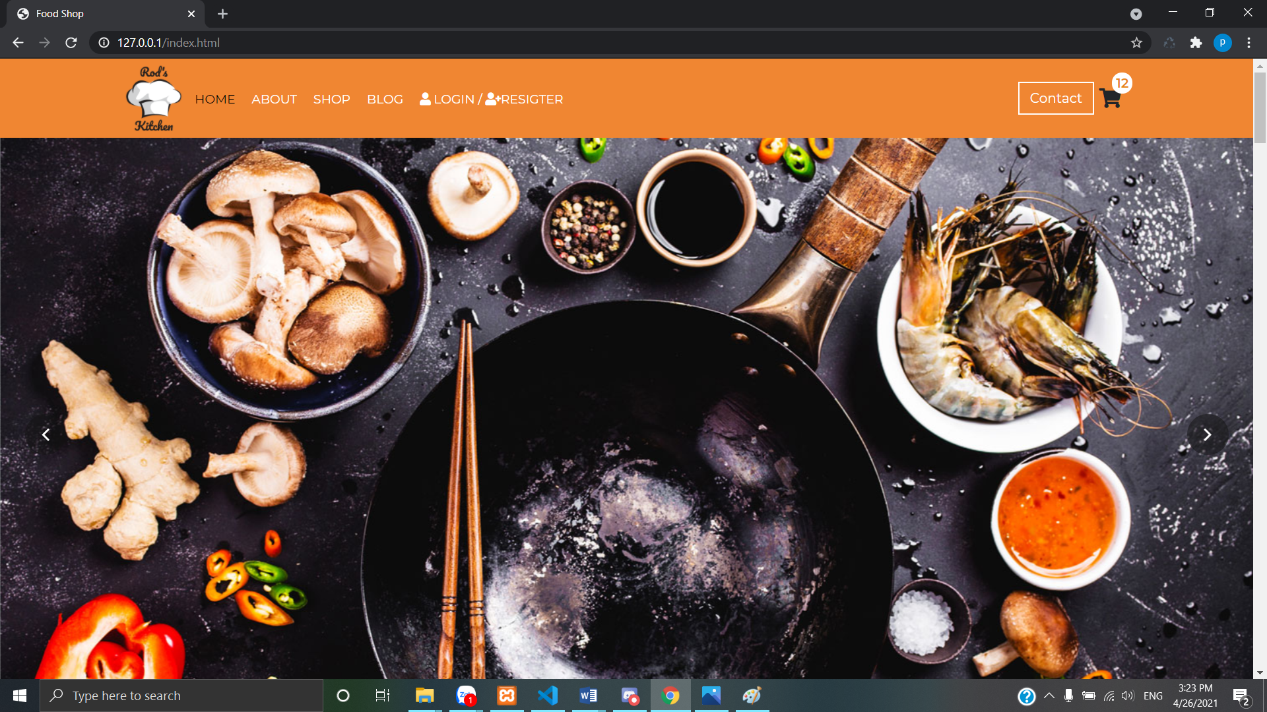

(Generating CRS and Building a Prototype)

## Project Report Template

### Quality Plan

* + **Review Activities** (Review meeting participants, frequency and so on)

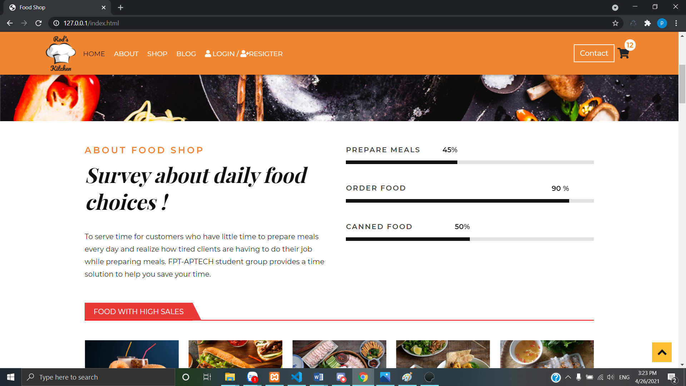

* + **Testing Activities** (Final Test)

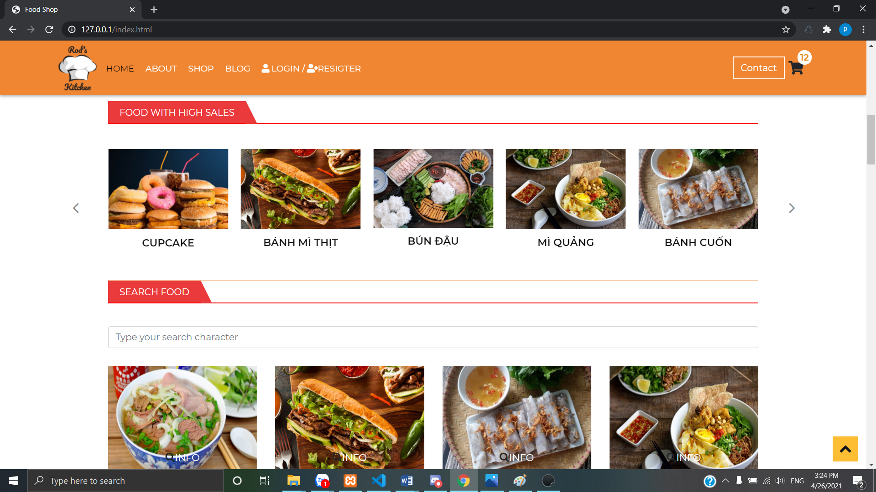

* + **Backup and Recovery Strategies** (In case of disk crash, network failures, and so on)

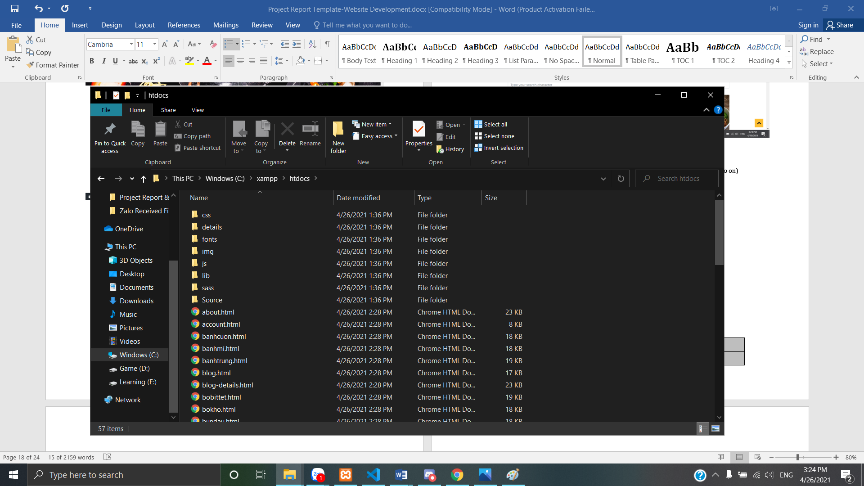

|  |  |  |
| --- | --- | --- |
|  | **Prepared By (Student)** |  |
| **Date** | 04-26-2021 |  |

## Project Report Template

|  |  |  |
| --- | --- | --- |
| **Design Plan:** | **Document Name: GUI Standard Document** | **SWD/Form No. 4** |
| **Effective Date:** | **Version: 1** | **Page No.** |

### Document Design

|  |  |
| --- | --- |
| **Property** | **Value** |
| Document Theme and Color Scheme | Web Order, orange |
| Form-Background Color | Orange, white and black is the main color |
| Title-Font Size | 20-50 |
| Title-Font Color | White , Black |
| Title-Font Style | Arial |
| Title-Alignment | Center |
| Background color of Controls on the form | Pink , White , black |
| Foreground color of Controls on the form | Pink , White , black |
| Control Caption-  Font Size | Review , Subrise Us , Contact Us  30-50 |
| Control Caption- Font Color | Review , Subrise Us , Contact Us  White , black , pink |
| Control Caption- Font Style | Review , Subrise Us , Contact Us  30-50  30-50 |
| Control caption and controls-Alignment | Center |
| Command button-Alignment | Left |

|  |  |  |
| --- | --- | --- |
|  | **Prepared By (Student)** |  |
| **Date** | 04-26-2021 |  |

Project Report Template

|  |  |  |
| --- | --- | --- |
| **Design Plan:** | **Document Name: Interface Design Document** | **SWD/Form No. 5** |
| **Effective Date:** | **Version: 1** | **Page No.** |

**1. List of forms to be created**

|  |  |  |
| --- | --- | --- |
| **Page/Form Name** | **Description** | **Controls on the Page/Form** |
| Home  R | Home page of web | Home page |
| Register | Register page | User can register here |
| Login | Login Page | User can login here |
| Shop | Menu of all food | Search , fill , Oder |
| About Us | Information of Us | Infor to contact or invites |
| Contact Us | Form contact to us | Contact with us for comment |

|  |  |  |
| --- | --- | --- |
|  | **Prepared By (Student)** |  |
| **Date** | 04-25-2021 |  |

Project Report Template

|  |  |  |
| --- | --- | --- |
| **Design Plan:** | **Document Name: Interface Design Document** | **SWD/Form No. 6** |
| **Effective Date:** | **Version: 1** | **Page No.** |

1. **Process/Module Name**

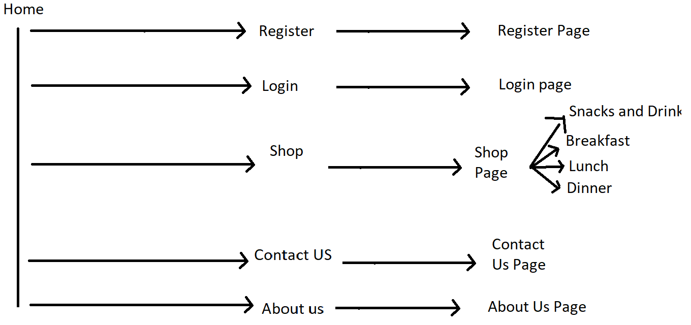

1. **Process/Module Description and Details**



|  |  |  |
| --- | --- | --- |
|  | **Prepared By (Student)** |  |
| **Date** | 04-25-2021 |  |

Project Report Template

|  |  |  |
| --- | --- | --- |
| **Design Plan:** | **Document Name: Task Sheet** | **SWD/Form No. 7** |
| **Effective Date:** | **Version: 1** | **Page No.** |

|  |  |  |  |  |  |
| --- | --- | --- | --- | --- | --- |
| **Date:** | **Project Plan/ Milestone** | **Work Specification** | **Status of the Activity** | **Remarks** | **Responsibility** |
| 04-24-2021 | Font End Done | Show home page , shop page with items, .. | Good | Need to change something | Complete Html , Css , Boostrap , … code |
| 04-25-2021 | Json | Add cart function, payment | Good | Try to do | Complete Add cart function, payment |
| 04-26-2021 | Complete Font end , Json text , checking around web | Keep check web | Good | Completed all today | Completed all today |
|  |  |  |  |  |  |
|  |  |  |  |  |  |
|  |  |  |  |  |  |

|  |  |  |
| --- | --- | --- |
|  | **Prepared By (Student)** |  |
| **Date** | 04-26-2021 |  |

Project Report Template

**Final Check List**

|  |  |  |
| --- | --- | --- |
| **Design Plan:** | **Document Name: Final Check List** | **SWD/Form No. 8** |
| **Effective Date:** | **Version: 1** | **Page No.** |

|  |  |  |
| --- | --- | --- |
| **S.No** | **Aspect Tested** | **Suggestion/Remarks** |
| 1. | Have all the modules been properly integrated and are they completely functional? | Yes |
| 2. | Does each unit meet its objective and purpose? Are all the validations happening properly? | Yes |
| 4. | Is the GUI design consistent all over? | Yes |
| 5. | Are the codes working as per specification? | Basic |
| 6. | Does the application’s functionality resolve the client  problem, and satisfy his/her needs completely? | It can |
| 7. | Have the hardware and software been correctly chosen? | Yes |
| 8. | Additional features and utilities that give value addition to the entire project. | Done |

|  |  |  |
| --- | --- | --- |
|  | **Prepared By (Student)** |  |
| **Date** |  |  |

## Project Report Template

# Source Code

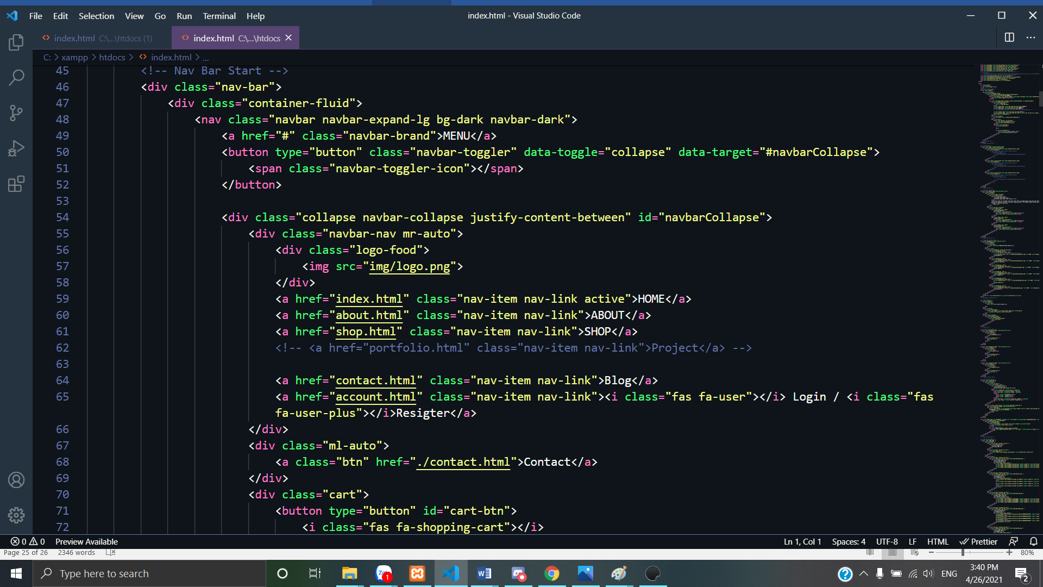

# User Guide

### System Requirements:

* 1. **Host the Site:**